DAA ASSIGNMENT
CHEBROLU LIKHITH VINAY
CH.SC.U4CSE24208

1)Write a program to find the sum of first n natural numbers using user-defined function.
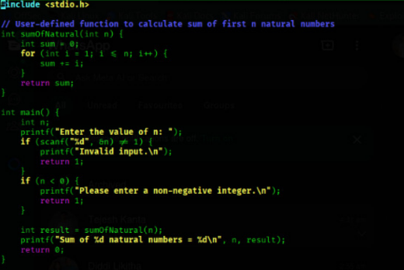
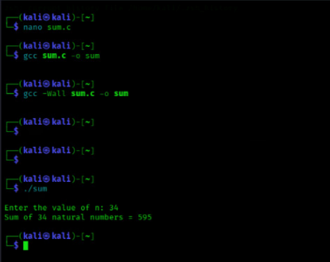
2)Write a program to find the sum of squares of first n natural numbers using user-defined function.
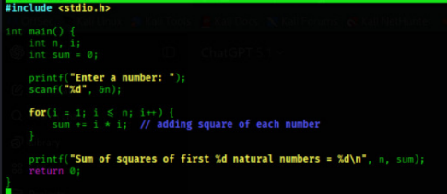
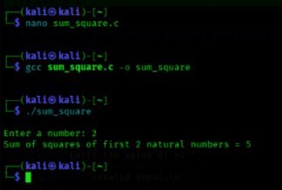
3)Write a program to find the sum of cubes of first n natural numbers.
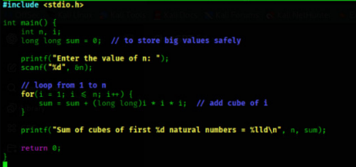
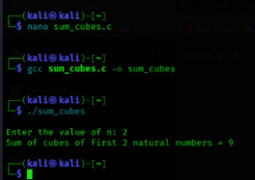

4) Write a program to find factorial of a natural number using recursive function.
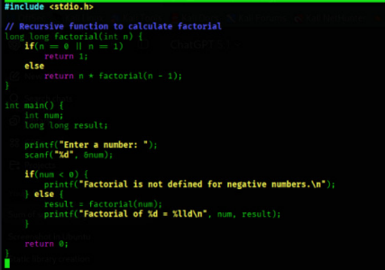
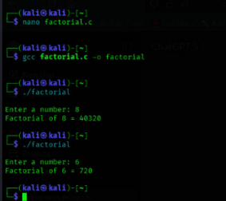

5) Write a program to transpose a 3×3 matrix.
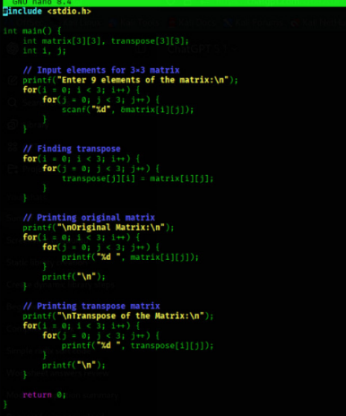
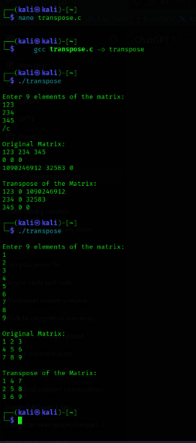
6) Write a program to print the Fibonacci series up to a given number using user-defined function. (For first n natural numbers)
